**Practice Questions on Sets and Functions**

1. Which of the following is not a Set?

* Organization of utensils in the kitchen
* Shopping malls as there will be separate and well defined portions for different kind of things
* Playlists in your mobile are organized according to genres
* Collection of beautiful songs

1. An empty set can contain “0” as one of the elements

* True
* False
* Cannot say anything

1. If U = {1, 3, 5, 7, 9, 11, 13}, then which of the following are subsets of U.

* B = {2, 4}
* A = {0}
* C = {1, 9, 5, 13}
* D = {5, 11, 1}

1. Which of the following sets is a universal set for the other four sets?

* Set of even natural numbers
* Set of odd natural numbers
* Set of natural numbers
* Set of negative numbers
* Set of integers

1. If A = {2, 3, 4, 5}     B = {4, 5, 6, 7}     C = {6, 7, 8, 9}     D = {8, 9, 10, 11}, find

A U B, B U C, (A U B) U C

1. If A = {4, 6, 8, 10, 12} B = {8, 10, 12, 14} C = {12, 14, 16} D = {16, 18}, find

A ⋂ B, B ⋂ C, B ⋂ D, (A ∪ D) ∩ (B ∪ C)

1. If A = {1, 2, 3, 4, 5} what is the cardinality of A

* 1
* 2
* 4
* 5

1. Let Color C = {R, B, G} and Size S = {S, M, L}. Find the Cartesian product of C and S
2. Which of the below lists is equal to the list L = {1, 2, 3}

* A = {1, 3}
* B = {2, 1, 3}
* C = {3}
* None of the above

1. See the diagram below

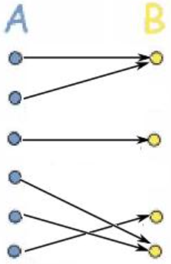

The function from Set A to B is:

* A general function
* Injective but not Surjective
* Surjective but not injective
* Bijective

1. See the diagram below:

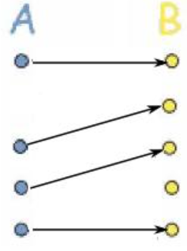

The function from Set A to B is:

* A general function
* Injective but not Surjective
* Surjective but not injective
* Bijective

1. If f(x) = 3x − 1 and g(x) = x2, then what is (f ° g)(x)?

* x2 -1
* 3x2 -1
* 9x2 -1
* x2 (3x-1)

1. If f(x) = 1/x for x ≠ 0, then what is (f ° f)(x)?

* X
* 1
* x2
* 1/ x2

1. f and g are both defined on the set of real numbers and c is a constant  
   f(x) = cx − 3  
   g(x) = cx + 5  
     
   If (f ° g)(x) = (g ° f)(x) for all values of x, what is the value of c?

* 0
* 1
* 4
* 8